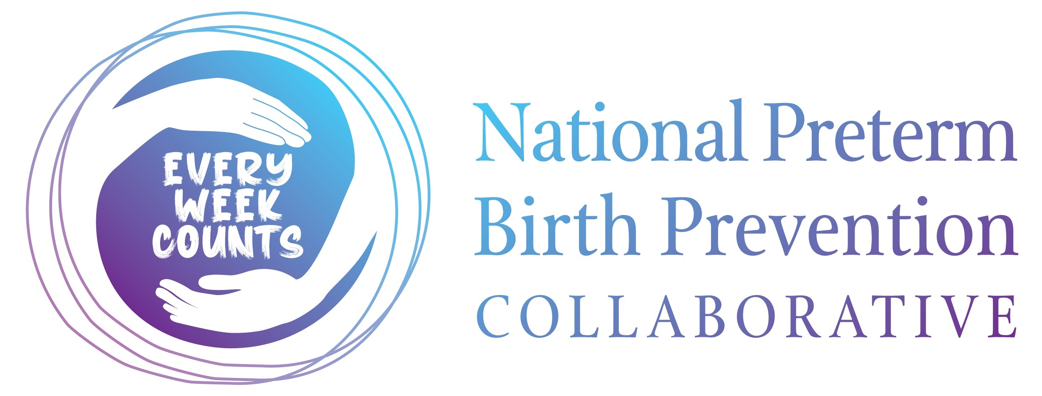 **MEDIA RELEASE**

**World Prematurity Day 2023: [Enter hospital/health service name] showcases its key role in National Preterm Birth Prevention Collaborative**

Monday, 13 November 2023

National efforts underway to safely prevent preterm and early term birth and its far-reaching impacts will together mark World Prematurity Day 2023 on Friday, 17 November.

A staggering 1 in 12 babies in Australia is born premature; for Aboriginal babies, this rate is almost double at 15%. In Australia, more than 26,000 babies are born preterm each year and more than 13.4 million globally. In 2020, preterm birth was responsible for more than 1 million deaths worldwide.

The [enter hospital/health service name] are a key part of the Every Week Counts National Preterm Birth Prevention Collaborative – a national program which aims to safely reduce preterm and early term birth across Australia by 20% through supporting hospitals in the adoption of evidence-based changes in clinical care.

Those born at the earliest gestational ages may suffer from severe and life-long problems such as cerebral palsy, developmental delay or blindness. For those born at a later gestation, even approaching full-term, there may be behavioural and learning problems.

This Commonwealth-funded national program involves obstetricians, midwives, GPs, sonographers, neonatologists together with consumers and quality improvement experts from more than 63 Australian maternity hospitals.

These hospital teams, representing every state and territory, range from the very largest tertiary services to key services in regional and remote communities providing local care.

During the Collaborative, [enter hospital/health service name] has been supported to accelerate its learning and develop reliable systems to ensure all women are offered the care and public health information that is known to reduce early birth. Key system improvements made at [enter hospital/health service name] include:

To mark World Prematurity Day 2023, [enter hospital/health service name] will be…

Chair of the Australian Preterm Birth Prevention Alliance, Professor John Newnham AM, pointed to the Collaborative as being a truly national force aiming to strategically lower the rate of preterm birth.

“Being born too early remains the leading cause of death and disability in children up to five years of

age in the developed world,” Prof Newnham said.

“For decades, preventing this major complication of pregnancy has needed to be one of our highest priorities in healthcare. We now have a whole of nation effort in place to lower the rate of harmful early birth in Australia.”

In 2021, the federal Government announced funding for the Australian Preterm Birth Prevention Alliance to support spread of its recommended approach to safely prevent preterm birth across Australia including the implementation of The Every Week Counts: National Preterm Birth Prevention Collaborative.

The joint collaboration between the Australian Preterm Birth Prevention Alliance, Women’s Healthcare Australasia (WHA), the Institute for Healthcare Improvement (IHI), and Safer Care Victoria, has adopted methods that have been successfully employed by hospitals around the globe for over 25 years.

To find out about more about the National Collaborative, and what care is being recommended to reduce risk of preterm birth, visit [Women’s Healthcare Australasia’s website.](https://women.wcha.asn.au/collaborate/breakthrough-collaboratives/the-national-preterm-birth-prevention-collaborative/)

The 2023 edition of the Every Week Counts magazine is valuable resource for all pregnant women and those considering a pregnancy. It contains expert editorial relating to the key interventions to prevent early birth, preconception and pregnancy care, and the latest from the National Preterm Birth Prevention Program. You can view the view the [online edition here.](https://pretermalliance.com.au/everyweekcountsmagazine)

**ENDS**

**Media contact:** Richie Hodgson, 0408 128 099, [richie.hodgson@uwa.edu.au](mailto:richie.hodgson@uwa.edu.au)

**Media opportunity:** Chair of the Australian Preterm Birth Prevention Alliance, Professor John Newnham AM is available for follow up media comment.